## SMART EMBEDDED SYSTEM FOR POTHOLE DETECTION

Submitted in the requirements of the research internship By

NSMP Kiran 21ECB0B36

K Ajay Kumar 21ECB0B28 T Veera Kumar 21ECB0B62 T Veera Ganesh 21MEB0A64

MVS Srimanth 21ECB0B33

Guided by:

#### Prof P. Muralidhar



**DEPARTMENT OF ELECTRONICS AND COMMUNICATION ENGINEERING**

**NATIONAL INSTITUTE OF TECHNOLOGY, WARANGAL**

**2024**

# CERTIFICATE

I hereby certify that we, NSMP Kiran (21ECB0B38), K Ajay Kumar (21ECB0B28), T Veera Kumar (21ECB0B62), T Veera Ganesh (21MEB0A64),MVS Srimanth(21ECB0B33) served as a Research Intern at National Institute of Technology, Warangal. We actively participated in the research and have successfully completed a Project titled “SMART EMBEDDED SYSTEM FOR POTHOLE DETECTION” We were involved in various aspects of research process, including literature review, data collection, analysis, and report writing. The findings and conclusions presented in this report are the result of my work during the internship.

#### Prof. P Muralidhar

Professor

Department of Electronics and Communication Engineering National Institute of Technology, Warangal – 506004 Telangana, India.

**ACKNOWLEDGEMENT**

I would like to express our deepest gratitude to my faculty in-charge **Prof. P Muralidhar**, Professor, Department of Electronics and Communication Engineering, National Institute of Technology, Warangal for his constant supervision, guidance, suggestion and encouragement during this internship duration.

# CONTENTS

| **CONTENTS** | **PAGE NO.** |
| --- | --- |
| **1. CERTIFICATE** | **2** |
| **2. ACKNOWLEDGEMENT** | **3** |
| **3. INTRODUCTION** | **5** |
| **4. REVIEW OF LITERATURE** | **6** |
| **5. REPORT ON THE PRESENT INVESTIGATION** | **7** |
| **5.1. SYSTEM DESIGN AND DEVELOPMENT** | **7** |
| **5.2. DATA COLLECTION AND ANALYSIS** | **10** |
| **6. RESULTS AND DISCUSSIONS** | **12** |
| **7. SUMMARY AND CONCLUSIONS** | **15** |
| **8. REFERENCES** | **16** |

1. **Introduction**

In recent years, road safety has become a critical concern, with potholes posing significant risks to both drivers and vehicles. Addressing this issue, we present an advanced road safety system that leverages cutting-edge technology to revolutionize pothole detection and management. By integrating high-resolution cameras, ultrasonic sensors, and GPS technology, our system offers a highly accurate and efficient solution for identifying and prioritizing road repairs.

The system works by equipping vehicles with strategically placed high-resolution cameras that capture clear images of potholes in various weather conditions. Concurrently, ultrasonic sensors detect changes in ground clearance as the vehicle passes over these potholes. This data is seamlessly combined with GPS coordinates, creating an accurate and up-to-date map of road conditions.

One of the key innovations of this system is its ability to prioritize pothole repairs, ensuring that the most critical issues are addressed first. The captured images and precise locations of potholes are promptly related to municipal authorities, enabling timely and effective road maintenance. Additionally, the integration of GPS technology allows for real- time alerts to be sent to drivers, warning them of upcoming potholes and thereby enhancing navigation safety.

## Review of literature

***Introduction to Pothole Detection****:* Pothole detection has become a critical area of research due to the significant impact of road conditions on vehicle safety and maintenance. Various technologies have been proposed and implemented to identify and address potholes on roadways, ensuring timely repairs and reducing accidents.

***Existing Methods****:* Several methods have been explored in the literature for pothole detection:

* + ***Ultrasonic Sensors****:* Studies have shown that ultrasonic sensors are effective in detecting variations in road surface height. For example, the HC-SR04 sensor is widely used due to its ability to measure distances ranging from 2 cm to 400 cm.
  + *High-Resolution Cameras:* Camera-based detection systems capture images of the road surface, which are then analyzed using computer vision techniques. The Raspberry Pi Camera Module V2, offering 8 megapixels of resolution, is commonly used for this purpose.

***Comparison of Techniques****:* Each of these methods has its strengths and limitations:

* + ***Ultrasonic Sensors:***While ultrasonic sensors provide real-time distance measurements, their accuracy can be affected by environmental factors such as rain and fog.
  + ***High-Resolution Cameras****:* Camera-based systems offer detailed visual information, but their effectiveness can be compromised in low visibility conditions.
  + *GPS Systems:* GPS provides accurate location data, but the precision can be affected by signal strength and the surrounding environment.

***Gaps in Research****:* Despite advancements in pothole detection technology, there is a lack of comprehensive systems that integrate multiple sensors and real-time data processing to enhance detection accuracy under various conditions. This project aims to address these gaps by combining ultrasonic sensors, high-resolution cameras, and GPS technology.

## Report on the present investigation

### System design and development

* + - ***Experimental Setup****:* The system utilizes a Raspberry Pi 3B+ as the central processing unit, connected to five ultrasonic sensors (HC-SR04), high-resolution cameras (Raspberry Pi Camera Module V2), and a GPS module (NEO-6M). The sensors are strategically placed on the vehicle to detect changes in ground clearance, while the cameras capture images of the road surface.

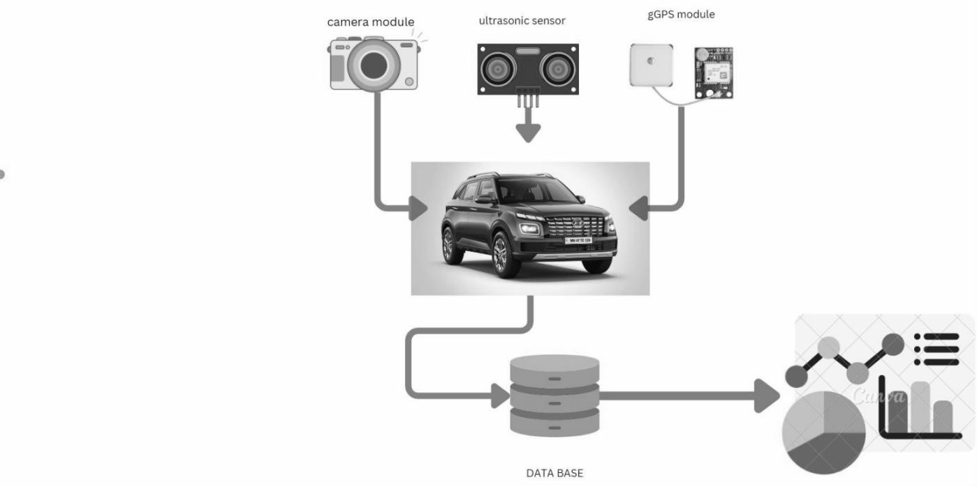

* + - ***Procedure Adopted:*** The system was developed by integrating the sensors and cameras with the Raspberry Pi, which processes the data in real-time. A dual validation process was implemented, where both sensor data and image analysis are required to confirm the presence of a pothole.
      * **Ultrasonic Sensors**: The system employs five ultrasonic sensors placed strategically at different locations of vehicle. These sensors measure the distance between the vehicle and the road surface. When the vehicle passes over a pothole, a sudden drop in ground clearance is detected by the sensors, indicating the presence of a pothole.

***Sensor at centre***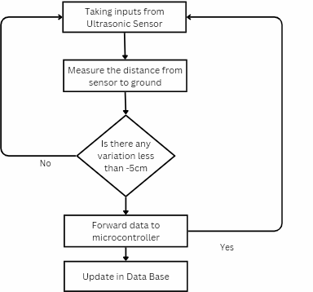

* + - * **High-Resolution Cameras**: High-resolution cameras are mounted on the vehicle to capture continuous images of the road surface. These images are processed in real-time using a machine learning algorithm running on the Raspberry Pi. The algorithm analyzes the image frames to detect patterns and features consistent with potholes.
      * **Sensor at tyre:**

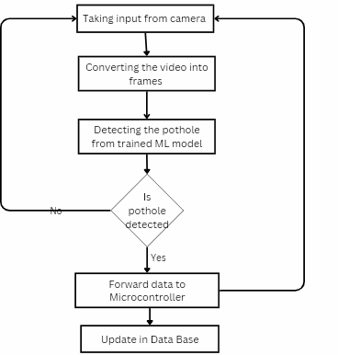

* + - * **GPS Module**: The GPS module records the exact geographic coordinates of any detected potholes. This location data is crucial for creating an accurate map of road conditions, which can be relayed to municipal authorities for efficient maintenance and repair operations.

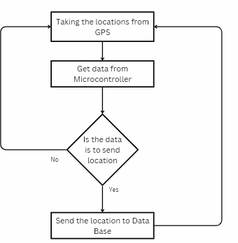

* + - ***Techniques Developed****:* A machine learning algorithm was developed to analyze camera images and detect potholes based on patterns and features. The system switches between sensor-based and camera-based detection depending on environmental conditions.
    - ***Methodologies****:* Data collection involved driving the test vehicle over various road surfaces under different weather conditions. The data was then processed using Python scripts running on the Raspberry Pi, and the results were stored in a SQL database.

### Data Collection and Analysis:

* + - *Data Collection:* Data was collected from the sensors and cameras during multiple test drives. The GPS module recorded the precise locations of detected potholes.
    - *Data Analysis:* The data was analyzed to validate the accuracy of pothole detection. Sensor readings were cross-referenced with image analysis results to confirm the presence of potholes.
    - *Experimental Results:* The system successfully detected potholes with a high degree of accuracy. The integration of GPS data allowed for the creation of an up-to-date map of road conditions.
    - 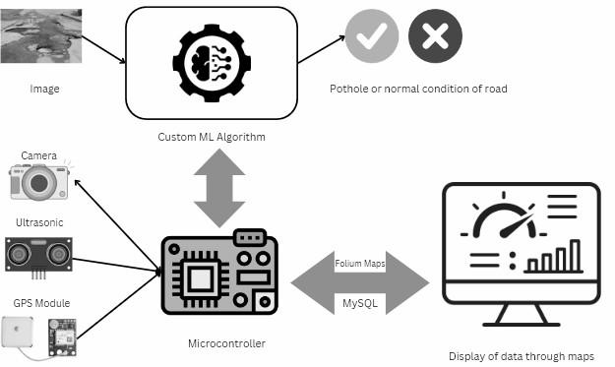

**Results and Discussion**

* + ***Evaluation of Findings****:* The system demonstrated robust performance in detecting potholes. The dual validation process significantly reduced false positives, and the integration of GPS data ensured accurate reporting of pothole locations.

#### Our prototype with hardware:

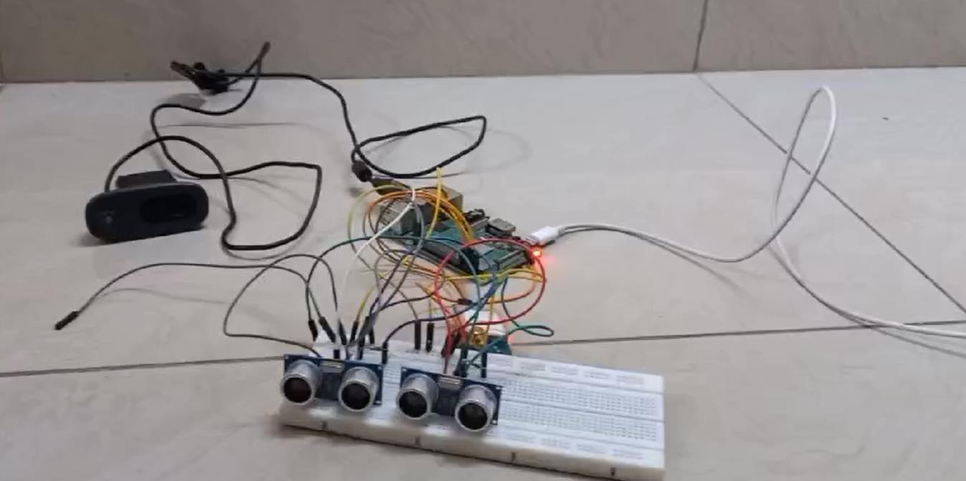

**Pothole detection:**

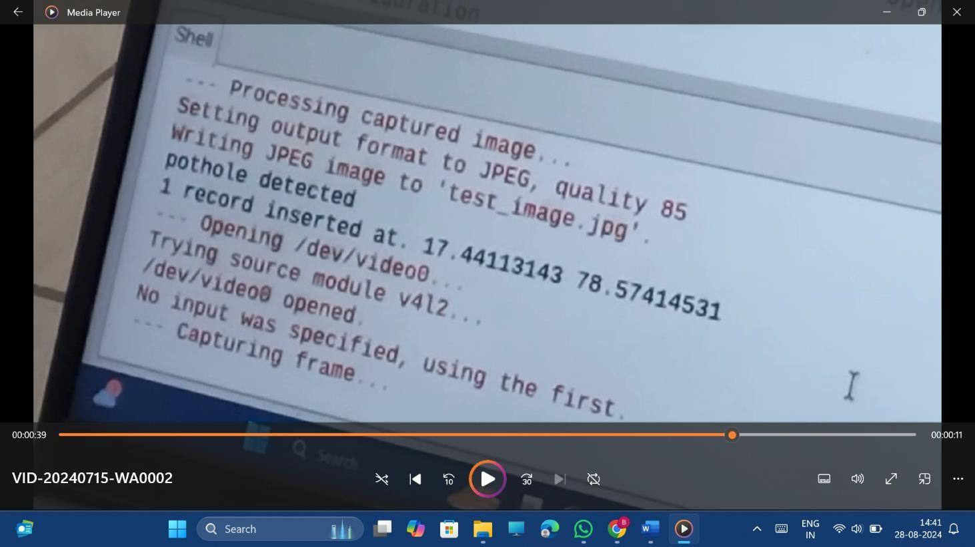Dashboard images:

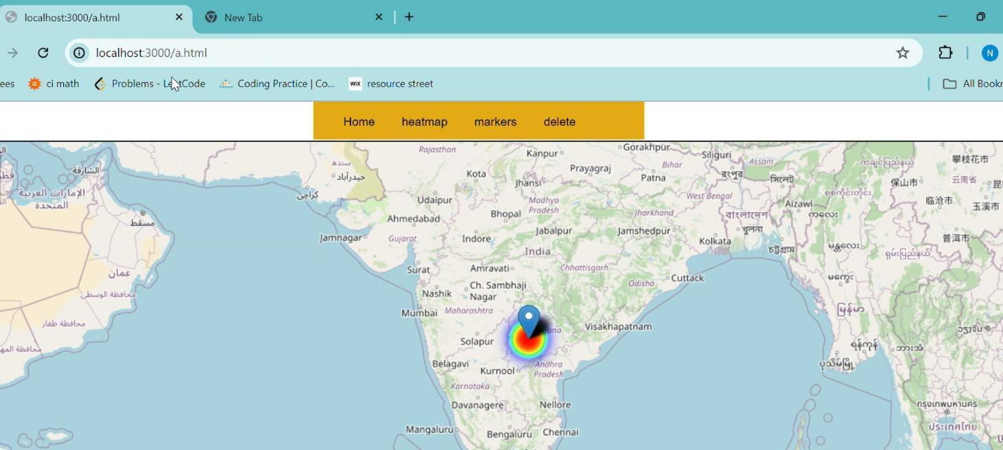

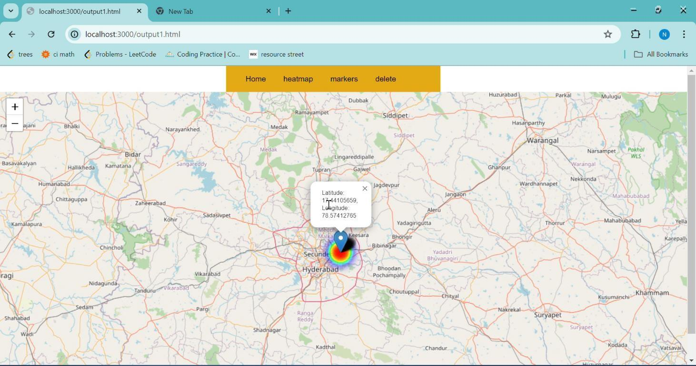

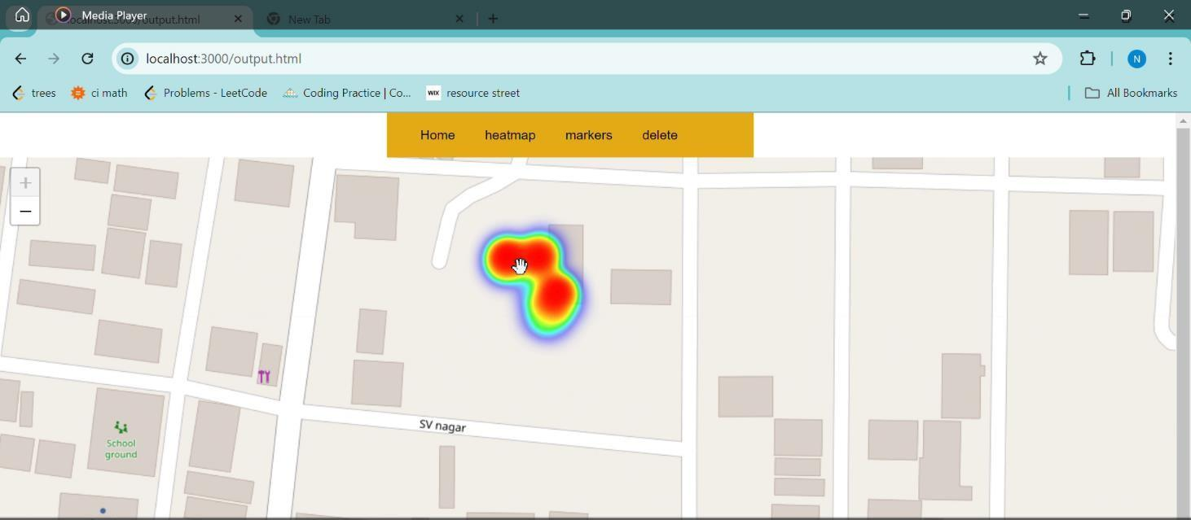

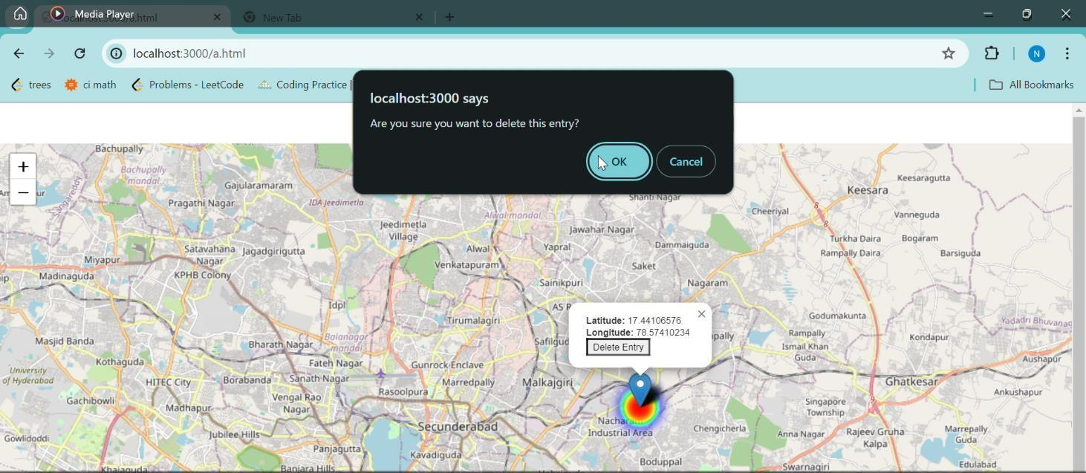

∙

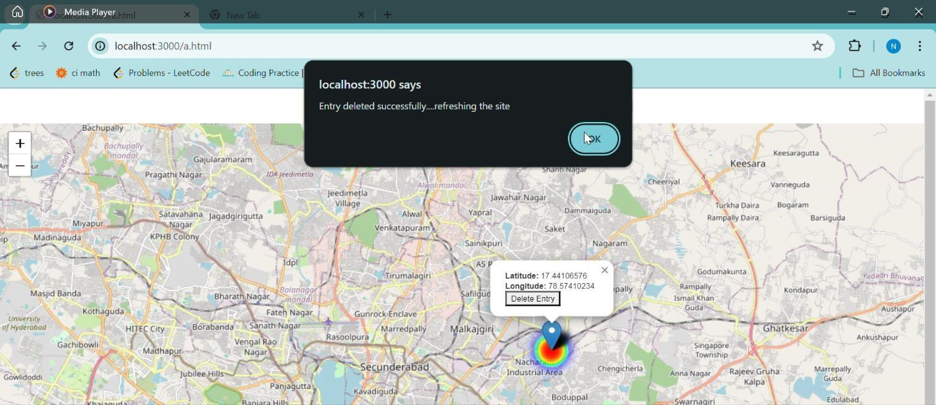

#### Video Link:

[https://drive.google.com/drive/folders/1Kw5X2FVPDY674uqW8W8yJZUrntMDWK4](https://drive.google.com/drive/folders/1Kw5X2FVPDY674uqW8W8yJZUrntMDWK4Z?usp=sharing) [Z?usp=sharing](https://drive.google.com/drive/folders/1Kw5X2FVPDY674uqW8W8yJZUrntMDWK4Z?usp=sharing)

**Summary and Conclusion**

* + **Summary of Work**: This project developed a comprehensive pothole detection system using ultrasonic sensors, high-resolution cameras, and GPS technology. The system was tested in various conditions and demonstrated high accuracy in detecting potholes.
  + **Conclusions**: The system effectively addresses the challenges of pothole detection by combining multiple technologies and real-time data processing. The results show that this approach can significantly improve road maintenance and safety.
  + **Scope for Future Work**: Future work could focus on refining the detection algorithms, integrating additional sensors, and exploring the use of advanced machine learning techniques to further enhance the system’s capabilities. Future enhancements could include integrating Lidar sensors for more precise distance measurements, improving the machine learning model for image analysis, and expanding the system to cover a larger geographical area.
  + References

1. **IEEE Xplore Digital Library** - Example Reference: "2019 IEEE 16th India Council International Conference (INDICON)."
2. **DOI (Digital Object Identifier) Systems** - Example Reference: Bhoyar, D., Khobragade, R. H., Mohod, S. K., & Fulzele, P. (2023). "IoT Based Pothole Detection and Alert System." 2023 1st DMIHER International Conference on Artificial Intelligence in Education and Industry 4.0 IDICAIEI 2023. <https://doi.org/10.1109/IDICAIEI58380.2023.10406520>
3. **Journal of Emerging Trends in Computing and Information Sciences** - Example Reference: Kim, T., & Ryu, S.-K. (2014). "Review and Analysis of Pothole Detection Methods." 5(8). [http://www.cisjournal.org](http://www.cisjournal.org/)
4. **Applied Sciences (Switzerland)** - Example Reference: Kim, Y. M., Kim, Y. G., Son,

S. Y., Lim, S. Y., Choi, B. Y., & Choi, D. H. (2022). "Review of Recent Automated Pothole-Detection Methods." In Applied Sciences (Switzerland) (Vol. 12, Issue 11). MDPI. <https://doi.org/10.3390/app12115320>

1. **Institutional Repositories** - Example Reference: McGill, A. L., Simmons, B. G., Querry, S. D., & Hammell, E. J. (2016). "Pothole Reporting System." <http://ideaexchange.uakron.edu/honors_research_projects/242>
2. **International Journal of Advanced Research in Biology Engineering Science and Technology (IJARBEST)** - Example Reference: Mohanaprakash, K., Brindha, S., Gowri, S., & Lathamaheswari, K. (2016). "Implementation of Vehicle Speed Limiting and Pothole Identification Using Ultrasonic Sensor."
3. **Proceedings from IEEE International Conferences** - Example Reference: Sb, S., Km, A. B., & Mishra, G. (2021). "Sensor Based Pothole Detection System." Proceedings - 2021 IEEE International Conference on Cloud Computing in Emerging Markets CCEM 2021, 15–22. <https://doi.org/10.1109/CCEM53267.2021.00013>
4. *2019 IEEE 16th India Council International Conference (INDICON).* (n.d.). IEEE.
5. Bhoyar, D., Khobragade, R. H., Mohod, S. K., & Fulzele, P. (2023). IoT Based Pothole Detection and Alert System. *2023 1st DMIHER International Conference on Artificial Intelligence in Education and Industry 4.0, IDICAIEI 2023*. <https://doi.org/10.1109/IDICAIEI58380.2023.10406520>
6. Kim, T., & Ryu, S.-K. (2014). *Journal of Emerging Trends in Computing and Information Sciences Review and Analysis of Pothole Detection Methods*. *5*(8). [http://www.cisjournal.org](http://www.cisjournal.org/)
7. Kim, Y. M., Kim, Y. G., Son, S. Y., Lim, S. Y., Choi, B. Y., & Choi, D. H. (2022). Review of Recent Automated Pothole-Detection Methods. In *Applied Sciences (Switzerland)* (Vol. 12, Issue 11). MDPI. <https://doi.org/10.3390/app12115320>
8. McGill, A. L., Simmons, B. G., Querry, S. D., & Hammell, E. J. (2016). *Pothole Reporting System*.

http://ideaexchange.uakron.edu/honors_research_projec[tshttp:](http://ideaexchange.uakro/)//[ideaexchange.uakro](http://ideaexchange.uakro/) n.edu/honors_research_projects/242

1. Mohanaprakash, K., Brindha, S., Gowri, S., & Lathamaheswari, K. (2016). IMPLEMENTATION OF VECHILE SPEED LIMITING AND POTHOLE IDENTIFICATION USING ULTRASONIC SENSOR. In *Online) International Journal of Advanced Research in Biology Engineering Science and Technology (IJARBEST)* (Vol. 2, Issue 10).
2. Saveetha Engineering College. Department of Electronics and Communication Engineering, Saveetha Engineering College. IEEE Student Branch, Institution of Electronics and Telecommunication Engineers (India), & Institute of Electrical and Electronics Engineers. (n.d.). *7th International Conference on “Smart Structures and Systems” : 23rd & 24th July, 2020*.
3. Sb, S., Km, A. B., & Mishra, G. (2021). Sensor Based Pothole Detection System. *Proceedings - 2021 IEEE International Conference on Cloud Computing in Emerging Markets, CCEM 2021*, 15–22. <https://doi.org/10.1109/CCEM53267.2021.00013>